/** enum BuildStyleID
{
CoreContour_Volume = 1, /** core contour on volume */
CoreContour_Overhang = 2, /** core contour on powder */
HollowShell1Contour_Volume = 3,/** shell1 contour on volume */
HollowShell1Contour_Overhang = 4,/** shell1 contour on powder */
HollowShell2Contour_Volume = 5,/** shell2 contour on volume */
HollowShell2Contour_Overhang = 6,/** shell2 contour on powder */
CoreOverhangHatch = 7, /** core hatch on powder */
CoreNormalHatch = 8, /** core hatch on volume */
CoreContourHatch = 9, /** core contour hatch */
HollowShell1OverhangHatch = 10, /** shell1 hatch on powder */
HollowShell1NormalHatch = 11, /** shell1 hatch on volume */
HollowShell1ContourHatch = 12, /** shell1 contour hatch */
HollowShell2OverhangHatch = 13, /** shell2 hatch on powder */
HollowShell2NormalHatch = 14, /** shell2 hatch on volume */
HollowShell2ContourHatch = 15, /** shell2 contour hatch */
SupportContourVolume = 16, /** support contour */
SupportHatch = 17, /** support hatch */
PointSequence = 18, /** point sequence */
ExternalSupports = 19, /** Externe Stützen */
CoreContourHatchOverhang = 20, /** HollowCore Konturversatz - Overhang */
HollowShell1ContourHatchOverhang = 21, /** HollowShell1 - Overhang */
HollowShell2ContourHatchOverhang = 22, /** HollowShell2 Konturversatz - Overhang */
};*/

In PBF, different regions of the part (like contour, core, support, or infill) can have different laser processing parameters for optimal part quality. For instance:
- Contours usually require slower scan speeds and lower power for accuracy and better surface finish.
- Core regions (infill) may use faster, higher-power scans for efficiency.
- Hollow shells are often used to reduce material usage and weight.
HollowShell1Contour_Volume : The outer boundary scan (contour) of the first hollow shell in the part.
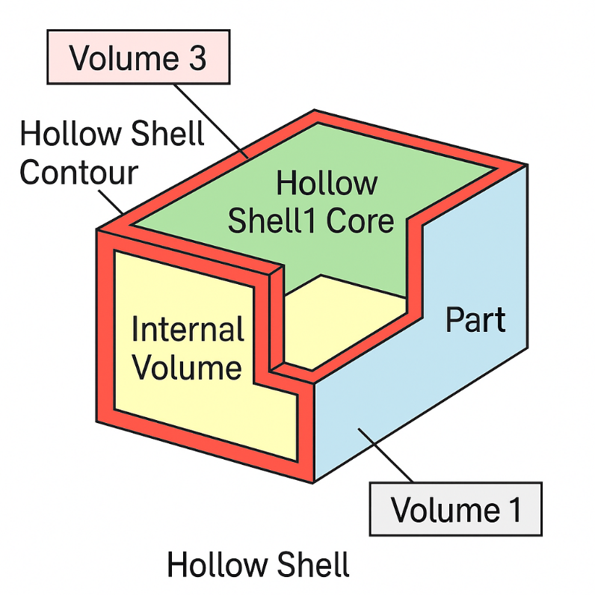

HollowShell1Contour_Overhang = 4,/** shell1 contour on powder */

• HollowShell1: The first designated hollow shell in the 3D part.
• Contour: Refers to the outer boundary scan path of that shell—important for surface finish and dimensional accuracy.
• Overhang: This specifies that the contour lies in an overhanging region, i.e., areas of the part that are not directly supported by material underneath (typically requiring adjusted scan strategies to reduce deformation, poor surface finish, or collapse).

In PBF, overhangs are prone to:
- Warpage
- Poor surface quality
- Incomplete fusion
So distinguishing normal contours from overhanging contours allows the machine to apply more suitable scan strategies for structural integrity and surface finish.

